In the Name of Allah, the Most Compassionate, the Most Merciful

ACLASSIFICATION of
ALMIZAN

THE INTERPRETATION OF HOLY QURAN

BOOK FIVE

CREATION SYSTEM

BY: Great Allameh
Seyyed Mohammad Hossein Taba-Tabaii

Edited, Summarized, Classified, and Translated by:

Seyyed Mehdi Amin
2016

"Allameh" Ayatollah Seyyed Mohammad Hossein Taba-Tabaii
&
His Masterpiece:
" ALMIZAN, THE INTERPRETATION OF HOLY QURAN"

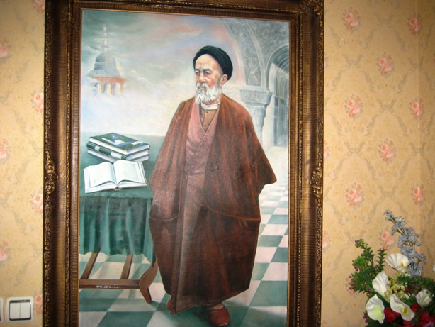

Image of Allameh ( Oil Painting. Work: Seyyed Mehdi Amin, 1370 )

CONTENTS:
) Red Lines was Translated )

BOOK five: CREATION SYSTEM

PART one : DIVINE SIGNS IN CREATION 6

Chapter One: Divine Signs and its Variation 7

What Sign Means ? 7
Signs Diversity and its Relationship with People's Degree of Understanding
Signs of Creation-World and its System
Thinking, Reasoning, and Reminding on Divine Signs 8
Diversity at Creation System and Diversity at Divine Signs
Chapter Two: Divine Signs at Day and Night

Divine Signs at Difference of Day and Night -
Regular Difference between Signs of Day and Night -
Sign at Night's Sleep and Daily Activities -

2
Chapter Three: Divine Signs in Nature and Natural Effects

Development Signs in Earth -
Presenting Divine Signs on Descent of Aliment from Sky -
What Signs are in Movement of Ship at sea? -
What Signs are in Wind-Currents and Airstream? -
Flight Rules as Divine Signs -
Call for Thinking on Flight Rules
What Signs are at Descent of Rain?
The Sign at Differences of Colors and Languages
Variety Signs in Nature-Colors
Sign at Stand-up and Stillness of Sky and Earth

Chapter Four: Divine Signs at Human Body

Sovereignty Signs of God on Earth and in Human -
Sign of Human Creation from Soil and its Stages -
What Signs are in Human Creation and other Living Creatures, and in its System? -

PART two : Creation System of the World

Chapter One: Common System and Specific System

Monotheism and the Creation System
One Creator for Creation System of Universe
The Common System of Creation
Specific Systems of Objects and Particles
Developments and Changes in Systems
Unity and Harmony in Creation System
Unity of Human System and the Global System -
Chapter Two: Creation System and Creator of Universe

Truth System and How God is Truth
Concept of Truth in Creation
Knowledge to Features of Creation and its Goal
Unity in Diversity and Diversity of Natural Properties and Elements
Attributing Initial Creation and Sustainability of Things to God Almighty
Creation and Devising of Heavens and Earth, its Relationship with Divine Guardianship and Mediation

PART three : The System of Couples

Chapter One: Couples System in Natures

Creation of Couples and Dominant System in all Creatures
Creation of Heavens and Earth and Creation of Couples
Development of Sky, Expansion of Earth, and Creation of Couples
Heavens and Earth Guarding, Beasts Spread out, and Couples Growth
Heavens Building, Earth Expansion, Couples Growth, and Survival Elements
Couples Creation, and Providing Means of Human Transportation and Movement
Sign of Fair Couples Growth
Couples System, Pollination in Plants and Effects of Rain and Gravity on Plant Growth
Evolution of Different Fruits Couples and Crops
Effect of Soil on Plant Growth and Herbal Couples

Chapter Two: Human Couples

Creation of Couple for Man, his Heart-Pleasing
Gift of Creation of Couple for Man, and Family Formation
Sign of Creation of Couple for Man, the Generation Factors of Mercy and Love
Creation the Couple for Man, Descent of Couples for Livestock, and their Reproduce

PART one

DIVINE SIGNS
IN
CREATION

Chapter One

Divine Signs and its Variation

What Sign Means ?

« تِلْکَ اياتُ اللّهِ نَتْلُوها عَلَيْکَ بِالْحَقِّ...!» (6/جاثيه)

"These are the Signs of Allah which
We recite for you in truth…!" (Holy Quran. Jaciye, 6. )

The word "Signs" is the plural of " Sign ", and means the symbols having indications, therefore, the genetic Signs of God, are the genetic affairs that by its outer existence signifies that the God Almighty is Unique in the Creation of the Universe, and has no partner in this work, attributing to all perfection attributes, and pure from all defects and needs.
Faith in these Signs, means believing in the implication of these signs to the Existence of God, that the requirement to have such Faith, is believing in God according the implication of this arguments, not the God that these arguments does not signify Him.
The "Verses" of the Holy Quran, has been called "Signs" because they indicate the Genetic Signs. Genetic Signs, as we said above, signify the Existence and attributes of God; or they have been called "Signs" that they indicate the ideological knowledge, practical commandments, or moral commands, the commands that God admires them and orders them and instructs His servants to act on them, because the contents of these Signs indicate these commandments have been descended by God. Belief in these signs is belief in their indications to God Almighty, inevitably is the belief in their implications, too.
The miracles, are also called the " Signs " because if they are such as resurrecting a dead person and the like, they should be of Genetic Signs, with the same genetic implications; and if they are such as Predictions or the Holy Quran itself, their indications will also refer to the Genetic Signs, because, by their existence, they imply the Existence of God Almighty and His attributes.
(Almizan v. 35, p. 259.)

Thinking, Reasoning, and Reminding
on Divine Signs

«اِنَّ فى ذلِکَ لاَيَةً لِقَوْمٍ يَتَفَكَّرُونَ...
اِنَّ فى ذلِکَ لاَياتٍ لِقَوْمٍ يَعْقِلُونَ...
اِنَّ فى ذلِکَ لاَيَةً لِقَوْمٍ يَذَّكَّرُونَ!»
(11 تا 13/نحل)

"Therewith He brings forth for you Plantations,
olives, date-palms, grapes, and all kinds of fruits and corns.
Verily, in this is a Sign[of Allah's Power]for men of thought !"

"For your benefit Allah has subjected by His Command
the night and the day, the sun and the moon, and the stars;
and in this there are Signs of Allah's Power for men of reason!"

"And whatsoever He has created for you of varying colour on this earth,
they are all reminding Signs of [Allah's Power]
for men who own of the Divine Insight! "
(Holy Quran. Nahl, 11-13)

These three types of Verses are three kinds of challenges which have been attributed to: First, for men who think; second, for men of wisdom; and third, for men who remind.
The reason is that, the first challenge at the Verse composed of simple arrangements which in its Use and Derive only a mere thought is enough:"Allah is the One Who sends down rain From the sky which is your drinking Water and also... Verily, in this is a Sign[of Allah's Power]for men of thought !" (Holy Quran. Nahl, 10-11. )

But the second challenge is composed of Scientific Arrangements which its undersating is not possible Except for scientists who understand the secrets of the celestial bodies and the earth, thus the only one can take result of this challenge that knows the movements and transfers of celestial bodies and the effects of that movements: "For your benefit Allah has subjected by His Command the night and the day, the sun and the moon, and the stars; and in this there are Signs of Allah's Power for men of reason!"

The third is also composed of general and philosophical arrangements that the only one can draw a conclusion and prove the Oneness of God in Lordship [Creator and Nurturer ] that remind the general rules of existence.
For example, knows that the universe which is constantly changing would probably require a material, and knows that all its ingredients lead to a similar general matter, and knows that it is obligatory for all the differences which is in material must lead to the non-material: Another factor is necessary to bring this General Material in thousands of Varieties: "And whatsoever He has created for you of varying colour on this earth, they are all reminding Signs of [Allah's Power] for men who own of the Divine Insight! "
(Almizan v. 14, p. 127.)

Translation is to be Continued…!

