In the Name of Allah, the Most Compassionate, the Most Merciful
Classification Of
ALMIZAN
THE INTERPRETATION OF HOLY QURAN
BY: Great Allameh Seyyed Mohammad Hossein Taba-Tabaii

BOOK THIRTY SIX

FROM HONAIN
TO TABOUK

EARLY ISLAMIC WARS WITH JEWS

Edited, Summarized, Classified, and Translated by:
SEYYED MEHDI AMIN
2016

"Allameh" Ayatollah Seyyed Mohammad Hossein Taba-Tabaii
&
His Masterpiece:
" ALMIZAN, THE INTERPRETATION OF HOLY QURAN"

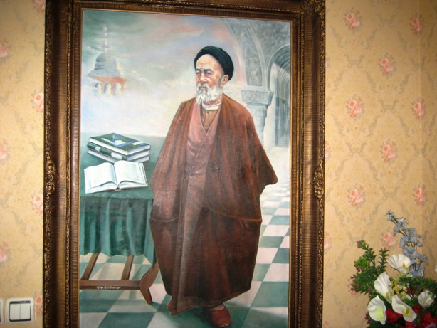

Image of Allameh ( Oil Painting. Work: Seyyed Mehdi Amin, 1991 )

CONTENTS:

BOOK THIRTY SIX

FROM HONAIN
TO TABOUK

EARLY ISLAMIC WARS WITH JEWS

) Red Lines have been Translated! )

Part One
From Honain to Tabouk
Islamic Wars with Jews and other Tribes

Chapter One: Battle of Honain with Tribes of Havazin and Saqif
Battle of Honain
Plurality of Troops and Pride of Muslims
Rreasons for Start of War and Arrangement of Enemy Troops
Equipments and Composition of Islamic Army
Beginning of War and Defeat of Muslims
Prophet's Command to Muslims for Resist, and Return of Runaways
The Killed, Captives, and Booties of Enemy
Divine Aid for Muslims, and Way of Enemy's Defeat
Spread of Booties and Protest of Ansar
The Dearest Booty of Ansar!
Forgiveness and Passing the Captives to their Families
Martyrs of the Battle of Honain
The Steady Steps at the Honian Front

Chapter Two: Beginning of Islamic Wars with Jews
Peaceful Treaties and Wars of Holy Prophet with Jews
Treaty-Breaking Infidel Jews - the Worst Creature on the Earth
Decisive Encounter with Jews
Jewish Betrayal in Violation of Treaties
God's Order to Fight with the Treaty-Breakers
Summary of the History of Muslim Wars with Jews
History of Jewish Migration to Medina
Treaty and War with the Jews of Bani-Qinqa
Treaty and War with the Tribe of Beni-Nazir
Treaty and War with the Jews of Bani-Qarizeh
The Battle of Kheybar

Chapter Three: Fighting with Jews of Beni-Nazir
The Jews Tribe of Beni-Nazir and their Breaking Treaty
Conspiracy of the Arab-Hypocrites and the Jews of Beni-Nazir
Details of Preparation and Results of the Battle of Beni-Nazir
Issue of Beni-Nazir War Booties and Command of its Spread
Ansar's Encounter against War Booties Spread

Chapter Four: Battle with Jews of Bani-Qarizeh

End of Ditch-Battle and Start of fighting with Bani-Qarizeh
Mediation between Jews and Muslims
Fate of Captivies and Failed Commanders

Chapter Five: Battle of Kheybar
Future War, the Kheybar Battle
A New Test, in a New War
Elimination of the Jihad from the Invalids
Details of the Kheybar Battle in Islamic Traditions
Beginning of War and Martyrdom of the Poet "Aamer"
Siege of Kheybar Castle, and Failure of Omar-ibn-Khattab to Open its Gate
The Flag of Islam being Handed to Ali(AS)!
Ali(AS) Root out the Gate of Kheybar Castle !
Prayer of the Messenger of Allah in Respect of Ali(AS)
Conquering the Jews Castles and Capturing Inhabitants
Conditions of Jewish Peace
"Fadak" Surrenders!
Poisoning of the Holy Prophet

Chapter Six: Battle of Tabouk
Preparation of Muslims to Fight with Rome
Sermon of Holy Prophet at Beginning of the Tabouk War
Violators of the Tabouk War
Rearwards from the Army
"Abu'zar" Came Horseless Behind the Army
Three Regretted Outcasts
Tabouk War, an Experiment between Hypocrisy and Loyalty
Hypocrites' Destructive Role in the War of Tabouk
Crossing the Hypocrites out from Tabouk War
Analyzing the Issue of Hypocrisy among the Early Muslims
Believers, and War Problems
Hypocrites' Sabotage in the Battle of Tabouk
Hypocrites' Plotting to Kill Holy Prophet in the Battle of Tabouk
Propaganda and Sabotage of Hypocrites in the Battle of Tabouk
Hours of Warfare Hardship and Affliction at Battle of Tabouk
Providers of Financial and Human Resources of War

The Translation is to be continued !

