In the Name of Allah, the Most Compassionate, the Most Merciful
Classification Of
ALMIZAN
THE INTERPRETATION OF HOLY QURAN
BY: Great Allameh Seyyed Mohammad Hossein Taba-Tabaii

BOOK TWENTY EIGHT

Men of the Cave Luqman the Wise
The Historical Events After Christ

Edited, Summarized, Classified, and Translated by:
SEYYED MEHDI AMIN
2016

"Allameh" Ayatollah Seyyed Mohammad Hossein Taba-Tabaii
&
His Masterpiece:
" ALMIZAN, THE INTERPRETATION OF HOLY QURAN"

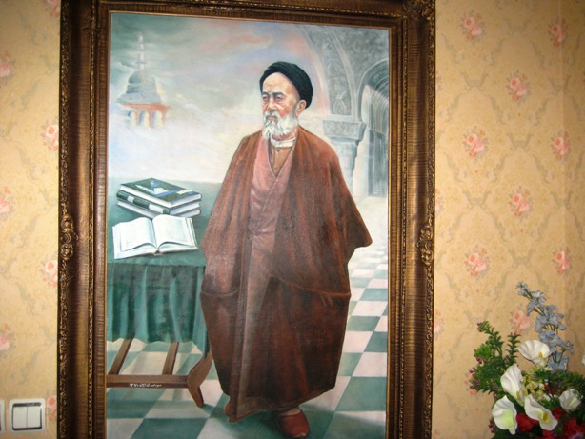

Image of Allameh ( Oil Painting. Work: Seyyed Mehdi Amin, 1991 )

CONTENTS:

BOOK TWENTY EIGHT

Men of the Cave & Luqman the Wise
The Historical Events After Christ

) Red Lines have been Translated )

Part One: The Divine Characters
and Historical Events after Christ

Chapter One: Luqman, the Wise
Luqman, and his Divine Wisdom
Preachings of Luqman to his Son
Resurrection, and Presence of Deeds to Reckoning
Observing the Requirements of Religon and its Duties
The Social Ethics
Luqman, and his Advices in Islamic Narrations
Famous Advices of Luqman to his Son:

1- Cognition and Worldview
2- Principles of Learning
3- Extent of Wealth and Property
4- Extent of Worship
5- Faith, Trust, and Piety
6- Education
7- Knowledge
8- Rules of Etiquette and Behavior

9- Fear and Hope
10- Pure Working for God
11- Indifference to the Worldly Riches
12- Worldly Aliment and Responsibility at Future Life
13- Control of Carnal Desires
14- Moderation
15- Outcome of friendship with the Debauchee

16- Humanly Duties
17- Virtue and Good Deeds
18- Attention to Work not to Wealth
19- Extent of Fondness to Worldly Things
20- Reckonable Responsibility
21- Attention to the End of Deeds
22- Good Conduct

Chapter Two: Men of the Cave

An Introduction to the History of the Men of the Cave
The Background Plan of the History of the Men of the Cave
Reason for Naming "the Men of the Cave and Rakeem(the Inscription) "
Summary of the Story of Men of the Cave, in Quran
Details of the Story of the Men of the Cave, and thier Personalities
Youth Uprising in the Way of God and their Movement
Start of Uprise from the Governer's Hall, Ends to Isolation
Distinguished Personalities of the Men of the Cave
Names of the Men of the Cave in Narrations
Departing to Cave and Men's Sleeping Style in the Cave
Cave's Geographic Location
Cave's Position towards the Sun
Disagreement on the Position of the Cave
Men's Sleep with Open Eyes, and their Body Displacement
Dog's Sleeping at Threshold
Fearsome Faces of Companions at Sleep
Analysis of the Main Parts of the Story
The Purpose of Men's Sleeping and their Wake Up
How does the State of Truth Appear?
The First Inquiry: How Long did We Sleep?
Number of Companions of the Cave
The First Action after Awakening
Fear of Restoration to Idolatry
An Analysis of the Spiritual Personality of the Companions of Cave
How was the Mystery of Cave's Companions Disclosed with an Antique Money?
Death of the Men of the Cave, and Building the Memorial Mosque
Different Opinion of the Monotheists and Polytheists about the Companions of the Cave
The Reason for Mentioning the Issue of the Memorial Mosque
Correct Numbers of the Companions of the Cave
Number of the Sleeping Years of the Companions of the Cave
Story of the Men of the Cave in Non-Islamic Books
Where is the Cave of Companion?
Cave of Efesos
Cave of Rojeib
Other Caves
Archaeological Discoveries in the Cave of Companion

Chapter Three: The Fellow of the Ditch-Fire
The Fellow of the Ditch-Fire Burning Christians
The History of the Fellow of the Ditch-Fire

Chapter Four: The Owners of the Elephants
Attack of the Owners of the Elephants to Destroy the Ka'ba
The Story of the Owners of the Elephants in the Traditions
The Tribe of Quraish's Commercial Caravans

Chapter Five: The Tribe of Tub'ba, and their Expectation of New Prophet

Tub'ba, and their Anticipation of the Emergence of New Prophet

The Translation is to be continued !

