In the Name of Allah, the Most Compassionate, the Most Merciful
Classification Of
ALMIZAN
THE INTERPRETATION OF HOLY QURAN
BY: Great Allameh Seyyed Mohammad Hossein Taba-Tabaii

BOOK TWENTY SEVEN

Teachings of Jesus,

Misinterpretations of Church

Edited, Summarized, Classified, and Translated by:
SEYYED MEHDI AMIN
2016

"Allameh" Ayatollah Seyyed Mohammad Hossein Taba-Tabaii
&
His Masterpiece:
" ALMIZAN, THE INTERPRETATION OF HOLY QURAN"

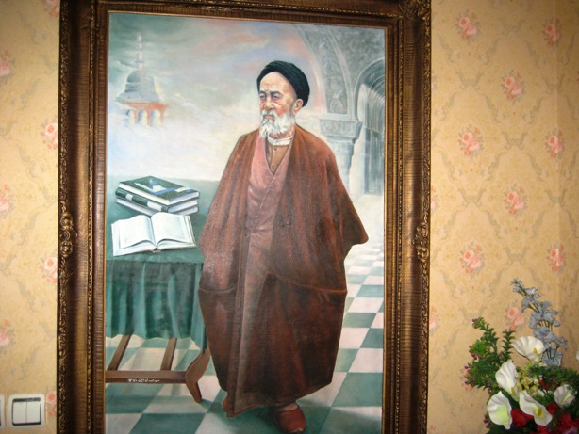

Image of Allameh ( Oil Painting. Work: Seyyed Mehdi Amin, 1991 )

CONTENTS:

BOOK TWENTY SEVEN

Teachings of Jesus,

Misinterpretations of Church

) Red Lines have been Translated )

Part One:Teachings of Jesus,
Misinterpretations of Church

Chapter One: How The Religion of Christ Was Distorted?

What did Jesus Say?
What the Christians Said about Jesus
What did the Gospels Say on Behalf of Jesus?
Summary of Christian Views about Jesus
What Kind "Son of God" Do they Consider the Christ?
Quran's Argument Rejecting the Divinity of Jesus
Comparing the gods of Pagans with Jesus
Testimony of Jesus against Christianity
Jesus as a Witness to the Deeds of his Followers
Jesus' Manner in Giving Testimony
Exaggeration of the People of Book in their Religion
Quran Blames the Exaggeration of the People of Book!
Punishment of Christians on Break of Covenant
Analysis of the Christian Prayer

Chapter Two: The Polytheistic Beliefs of Christianity

Sect 1- The Trinity (Three-Equals)

Backgrounds of the Deviations in the Religion of Christ
History of Trinity in India
History of Trinity with Buddhists
History of Trinity in Egypt
History of Trinity among other Ancient Nations
Deviation of Christianity from the Quranic Point of View
- A. Through the General Dialectics
- B. Through the Special Dialectics
The Polytheistic Aspects of Christian Beliefs
Beliefs of Christian Sects on the Deity of Christ
Polytheism Based on the Believe in Three gods or Trinity
Monotheism in Terms of Quran and Christianity
The View of the Current Christians about Deity of Jesus Christ
Jesus and his Mother's Being Creatures
Origin of the "Father and Son's Notion"
Invention of Monasticism in Christianity
Footnote:
- On Gospels and Christianity
- Trinity
- The "Cross" Sign
- Worship of Mary, and other Beliefs of the Church
- Christ Blaming the Christianity

Chapter Three: The Polytheistic Beliefs of Christianity

Sect 2- The Theory of Sacrifice

Background of the Sacrifice among the Ancient Nations
Background of the Sacrifice among the Hindus
Background of the Sacrifice among the Buddhists
The Theory of Sacrifice
Rejecting the Theory of Sacrifice by Quran
Jesus' Intercession instead of Sacrifice
1- Sacrifice
2- Intercession
Corruptions Caused by the Belief and Theory of Sacrifice

Part Two:History of Progress and
Deviation of Christianity

Chapter One: The Stages of Progress and Deviation of Christianity

Four Periods of the History of Christianity
Early Missionaries and Advancement of Religion among the General Public
The Roman Church and the Officialization of Religion in the Roman Empire
Start of Divisions and Protests against Religious Deviations
Rule of Roman Church, and Divergence of other Churches
Triple Split of Christianity: Catholic, Orthodox, Protestant
Decline of the Authority of Church, Resulting from Abuse of Religion
Analysis of the History of Christian Deviation from Monotheism to Polytheism
Who Shared in Alteration of the Teachings of Christ?
A Historical Document about the Invitation of Jesus(AS)
The Disguise in the History of Jews about Mary and Jesus(AS)
What Evidence Have the Jews in their Claims?

Part Three: Islam and Christianity

Chapter One: Jesus and Good News of Messenger of Islam

Good News of Jesus to Prophecy of Ahmad(PBUH)
The Name "Ahmad" in Gospel(Bible)
Ahmad and Muhammad "PBUH" in Islamic Traditions
Church Propaganda against Islam
"Mubahalah"(Cursing, Prove the Truth) with the Christians of Najran

The Translation is to be continued !

