In the Name of Allah, the Most Compassionate, the Most Merciful
Classification Of
ALMIZAN
THE INTERPRETATION OF HOLY QURAN
BY: Great Allameh Seyyed Mohammad Hossein Taba-Tabaii

BOOK TWENTY SIX

BEGINNING OF CHRISTIANITY

Zecharia, John,
Mary, and Jesus Christ^{(AS)}

Edited, Summarized, Classified, and Translated by:
SEYYED MEHDI AMIN
2016

"Allameh" Ayatollah Seyyed Mohammad Hossein Taba-Tabaii
&
His Masterpiece:
" ALMIZAN, THE INTERPRETATION OF HOLY QURAN"

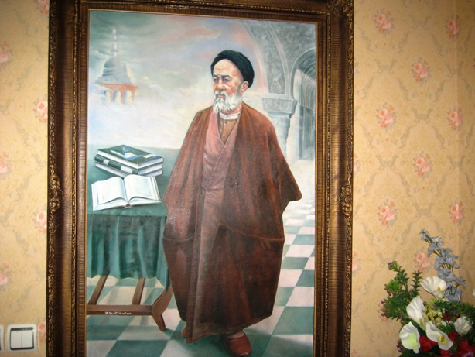

Image of Allameh ( Oil Painting. Work: Seyyed Mehdi Amin, 1991 )

CONTENTS:

BOOK TWENTY SIX

BEGINNING OF CHRISTIANITY

Zecharia, John,
Mary, and Jesus Christ^{(AS)}

) Red Lines have been Translated )

PART ONE
Part One: Zechariah and John(AS)

Chapter One: The Prophet Zechariah(AS)

Zechariah and his Guardianship of Mary
Zechariah and the Birth of Prophet John
How the Zechariah Prayed
Relevance of Mary's Miracle with Zechariah's Prayer
Explanation of the Prayer of Zechariah
Zechariah's Story in Quran and its Analysis
Simultaneous Prophecy of Zechariah, John, and Jesus(AS)
History of Zechariah and Jesus in the Bible

Chapter Two: Prophet John(Yahya.)
A Miracle, and Prelude for Birth of Jesus(AS)

Summary of the History of John's Life in Quran
Description of the Life and Death of John in the Traditions
Prophet John, and the Miracles of his Life
Miracle of Birth in an Untimely Period
What Clue asked Zechariah from God?
God's Commandment to John for Getting the Book
John's Knowledge at Childhood
John's Virtue and his High Qualities
God's Salutation on John
Details of John's birth in Quran
Relevance of Mary's Life with John's Birth
Naming of John(Yahya)
The Similarities between John and Jesus(AS)

Part Two: The Holy Mary and the Holy Jesus
Chapter One: The Holy Mary - A Truly Saintly Woman

Summary of the Life History of Mary in Quran
Description of the Birth of Mary in the Quran
Mary's Parents
Concept of "Liberating" Mary
How Did the Expected Birth of a Boy Change to a Girl?
The Qualifications of Holy Mary
Naming Mary
Mary's Life before Jesus' Birth
Mary's Life under the Protection of Zechariah
Mary's Worshiping Altar
Location of Descending Heavenly Food
Mary, the Mother of Jesus Christ(AS)
The Initial Encounter of Mary with Angel of Revelation and the Messenger of God
Mary's Getting Pregnant
Uttering the Mary's New-Born Jesus against the Slander of People
Testimony of the New-Born Jesus to his own Prophecy
Mary's Meeting and Discourse with the Angel
The Duties and Authorities of Mary(S)
Mary, and his Name and Mention in Holy Quran
Who Are the Descendants of "Imran?"
The Purpose of "Surah Maryam", and the Stories Mentioned therein
Believers in the Divinity of Mary in Christianity

Chapter Two: Jesus Christ, from Birth to Prophecy

Who is the Jesus of Quran?
Summary of the Life History of Jesus in the Quran
Details of the Birth of Jesus Narrated in Quran
Name and Naming of Jesus (AS)
- Word
- Christ
- Jesus, the Son of Mary
Informing the Position and Status of Jesus at Time of Birth
Similarity of the Birth of Jesus with the Creation of Adam(AS)

Chapter Three: The Principal Functions of Jesus' Mission

The two Main Tasks of the Mission of Jesus:
- Verification of the Torah
- Removing Certain Prohibitions
Jesus' Mission to the Children of Israel and all the People

Part Three: The Sharia of Jesus
and His Gospel

Chapter One: The Sharia of Jesus and the Holy Book of Gospel(Bible)

The Sharia of Jesus in the Quranic View
Judgment and Verdict on Basis of the Gospel
Gospel, the Book of Jesus(AS)
Three Distinct Aspects of the Gospel(Bible) in Terms of the Quran
There is Only One Gospel in Terms of the Quran
Accepting the Current Gospels in View of Quran
History of the four Gospels:
- THE Matthew's Gospel
- the Gospel of Mark
- The Luke's Gospel
- The Gospel of John

A Footnote: About Gospels
A Footnote: Gospels from the Perspective of other Churches
Summary of the Invitation of Jesus in the Present Gospel
Abandoned and Blacklisted Bibles: (The Gospel of Barnabas)
The Torah and the Gospel at the Time of the Quran's Descent
Why the Torah and the Bible Are not in Use?

Part Four: The Miracles of Jesus(AS)

Chapter One: The Miracles of Jesus(AS)

Miracles of Jesus in Quranic Verses
Speaking of New-Born Jesus in the Cradle
Types of Blessings and Privileges Granted to Jesus(AS)
Descent of Heavenly Food
Story of the Christ's Bread and Fish in the Gospel of John
Analysis of Jesus' Prayer Requesting the Heavenly Food
How did the Disciples Correct their Request?
Request of Heavenly Food and the Manner of Jesus in Prayer
The Features of the Prayer on Request of Heavenly Food

Part Five: The Story of
the Death of Jesus(AS)

Chapter One: End of the Jesus' Earthly Life
Duration of the Jesus' Life Time
The End of Jesus' Career
Tale of the Last Supper
Jesus in the Heavens
The Quran's View on the Claim of Killing the Jesus(AS)
Elevation of Jesus to Heaven
Secondary Restoration of Jesus(AS)

Part Six: The Disciples of Jesus(AS)

Chapter One: The Disciples and Followers of Jesus

Choosing the Disciples and Recieving their Allegiance
Reasons to Select the Disciples
Establish of Christian Invitation by Choosing the Disciples
Who is the Disciple?
Disciples, and their Getting the Revelation and Prophecy
The Sincerity and Faith of the Disciples
The Ansar-ul-Allah(Helpers of God) of Muslims and Christians
Supremacy of the Followers of Jesus
The Disciples of Jesus in "Antioch" and "Habib the Carpenter"
Peoples' Considering the Apostles as Bad Omen
Condition of Martyring the Fourth Messenger
Destroying the City of Antioch

The Translation is to be continued !

