In the Name of Allah, the Most Compassionate, the Most Merciful

ACLASSIFICATION of
ALMIZAN

THE INTERPRETATION OF HOLY QURAN

BOOK TWENTY ONE

CHILDREN OF ISRAEL
Second Dynasty of
Sons of Abraham(AS)

BY: Great Allameh Seyyed Mohammad Hossein Taba-Tabaii
Edited, Summarized, Classified, and Translated by:
Seyyed Mehdi Amin
2016

"Allameh" Ayatollah Seyyed Mohammad Hossein Taba-Tabaii
&
His Masterpiece:
" ALMIZAN, THE INTERPRETATION OF HOLY QURAN"

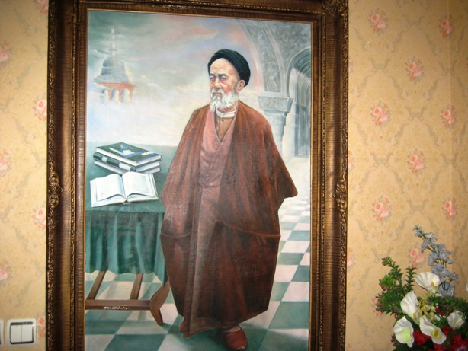

Image of Allameh ( Oil Painting. Work: Seyyed Mehdi Amin, 1991 )

CONTENTS:

BOOK TWENTY ONE

CHILDREN OF ISRAEL Second Dynasty of Sons of Abraham(AS)

PART ONE: Children of Israel

) Red Lines have been Translated )

Chapter One: General History of the Children of Israel 5

Children of Israel, Offsprings of Pilgrims of Noah's Ark 5
Who Was Israel? 6
Tips on the Israeli Bondage
Summary of the Story of Moses(AS) in Quran
Moses' Story in the Torah
Reason for expression of Moses' History in Quran
Common Characteristics of Children of Israel with Quraysh

Chapter Two: Chidren of Israel after Moses 8

Story of the Children of Israel after Moses 8
State of the Torah after Moses 9
Twelve Tribes of Children of Israel
Chieftains of the Children of Israel
Jewish Deviations
Correcting Jewish Deviations by Quran

Part One
CHILDREN OF ISRAEL

Chapter One

General History of the Children of Israel

Children of Israel, Offsprings of Pilgrims of Noah's Ark

" وَآتَينا موُسي َالكِتابَ وَجَعَلناهُ هُديً لِبَني اِسرائيلَ...ذُرّيَّةَ مَن حَمَلنا مَعَ نوُحٍ ...."( اسری3)

"And We gave Mussa the Scripture and Appointed it a Guide for the Children Of Israil… The offsprings of those whom We carried in the Ark along with Nuh…!"
(Holy Quran: Assra, 3.)

Allah has given promises to pilgrims of Noah's Ark. After He saved the few righteous people on the earth from drowning, He stated:

" O, Nuh! Get down from The ship with Health!
and Blessings from Us which has been bestowed on you
And some nations who are with you!
And There are some nations in the world
That We shall give enjoyment and Provision to them; and then
a painful Torment from Us will overtake them!"
(Holy Quran: Hood, 48.)

At the beginning of Verse 3, Sura Assra, shows that the sending of Book to Moses and the Guidance of the Children of Israel through it is, in fact, a fulfillment to the same good promise that He had given to their fathers, the Pilgrims of the Noah's Ark.
And at the same time, the implementation of the Divine Tradition that was applied in the nations of the past. It is said that We sent Moses a Book and made it the Guidance of the Children of Israel, because the Sons of Israel are the sons of the same people whom We carried with Noah, and gave them the promise of health and blessings!
He says: This Tradition of Guiding and Leading, and the way of inviting to monotheism is exactly the same as Noah(AS) was the first practitioner of it in the human world, and by standing up with this Tradition, he gave his thanks to blessings of God and purified his servitude and worship to God.
The Almighty God thanked him for his service, and made his Tradition survive till the world survives, and saluted him in all the worlds. Until the Day of Resurrection, God Almighty made Noah(as) a partner in the every word of prayer and righteous deeds done by any human race!
From the Quranic Phrase:" And made his progeny to endure(on this earth!) (Saffat: 77, ) it is well understood that today's people are all the offsprings of Noah's sons and daughters!
(Almizan: V.25 , P.66)

Who Was Israel?

" اِلاّ ما حَرَّمَ اِسرائيلَ عَلي نَفسِهِ .... " ( آل عمران - 93)

" … except what Israel(Jacob) made unlawful for himself…!"
(Holy Quran: Ale'Omran, 93.)

The term "Israel" in the above Verse is " the Prophet Jacob(AS) ." The fact that he was called "Israel" is because he was a "Struggler" in the Path of God, and became" Victorious " by the means of God.
About the reason for such naming the people of the book say, "he, while wrestling with God in a place called " Pheaniel ", did dominate and conquer God!!!?
The issue of wrestling Jacob with God is mentioned in the Torah, but the Holy Quran denies it, and the human intellect also considers it as of impossibilities !!!
The Children of Israel are the offsprings of Jacob's sons. They originally lived like nomadic tribes, and later they were transferred to Egypt with the transfer of Yusuf(AS) as his family. Afterwards, the Pharaohs of Egypt took all these people of Israel into the land of Egypt, and treated them as Slave Captives, until the God Almighty by Moses saved them from Pharaoh and his way of treating.
(Almizan: V.6 , P.191 & 244)

Chapter Two

Chidren of Israel after Moses(AS)

Story of the Children of Israel after Moses

( A Historical Discussion )

During the time of Moses and Joshua, the people of Israel lived in the same way as people living with their Imam and their spiritual leaders, then the devising of their affairs fell in hand of judges like "Ehud" and "Gideon" and so on.
After that, the era of kings began between them. The first king who ruled over them is "Shawul", which the Holy Quran called him "Taloot". After the Taloot, their rule was with "David(AS)" and then with "Solomon(AS)".
After the Prophet Solomon, the kingdom was divided and their power was dispersed. However, the monarchs, such as "Rehoboam, Abu'am, Yushafat, Yehuram" and the likes of those who were about thirty, ruled over them.
But their power was destroyed, and the Babylonian kings prevailed them and seized Jerusalem, which is called: Holy House!
It was about six hundred years before Christ.

The king of Babylon was at that time "Bakht al-Nasr (Nebuchadnezzar)". Jews disobeyed his obedience. He sent his troops to their land and besieged and opened Jerusalem, and plundered the treasures of the king. They also took the Treasuries of Temple (al-Aqsi mosque) in this loot.
After that, they gathered about ten thousand of wealthy people, elders and industrialists and moved them to Babylon. In their place, there remained a group of poor or weak people.
Bakhat al-Nasr put over that insignificant number one of their own kings named "Seddikia", which was the last king, and ordered him to obey his commands.
It took about ten years for this to happen, until Sadqiya became a little strong and joined one of the Egyptian Pharaohs and disobeyed the Bakhat al-Nasr .
Seddikia's disobedience and his people made Batkh al-Nasr angry and led the army to their land and besieged their cities. The Jews were refugees to their castles and they were besieged for about a year and a half, but finally the famine and chaos were found between them.
Batkh al-Nasr stood in siege until he conquered the castles in 586 B.C., and ordered the murder of Jews and the destruction of their cities and castles after they opened the city. And they destroyed all their religious signs and turned the Temple (al-Aqsa Mosque) into a slope of soil.
(Almizan: V.6 , P.191)

State of the Torah after Moses(AS)

At this unfortunate event the "Torah" and the Coffin that was its place disappeared.
About 50 years the Jews lived in Babylon in the same way, while there was no news of their Holy Scripture, and nothing were seen of their temple or land except the hills of soil!!
Until Cyrus, the king of Iran, conquered Babylon and liberated the Israeli captives.
Cyrus appointed the famous "Ezra", one of his minions, as their governor, in order to return them to their own land and re-write their book of Torah, and rebuild the Temple, and eventually to return them to their original course of life.
Ezra, at the year of 457 B.C., brought the Israelites to Jerusalem again. Then began to collect and correct the "Old Testament books", which is the current Torah.
- It is worth to mention that the track record of "Current Torah" is interrupted and it has only been connected to Mosses through the one named "Ezra", which, of course, it causes many questions in the mind of readers, as follows:
1- The the said Ezra is not known to a researcher!
2- The measure of his knowledge and insight in the Torah is not clear!
3- The amount of his trusteeship for doing such a major work (ie. rewriting a religious book such as the Torah) is not clear!
4-It is not known what sources and documents he has collected from the books of current Torah?!
5- Upon what correct evidential documentary he has corrected the false narratives in the Torah?!!
(Almizan: V.6 , P.191)

The Translation is to be continued !

