In the Name of Allah, the Most Compassionate, the Most Merciful
Classification Of
ALMIZAN
THE INTERPRETATION OF HOLY QURAN
BY: Great Allameh Seyyed Mohammad Hossein Taba-Tabaii

BOOK THIRTY NINE

FOODS AND FEEDING

IN ISLAM

Edited, Summarized, Classified, and Translated by:
SEYYED MEHDI AMIN
2016

"Allameh" Ayatollah Seyyed Mohammad Hossein Taba-Tabaii
&
His Masterpiece:
" ALMIZAN, THE INTERPRETATION OF HOLY QURAN"

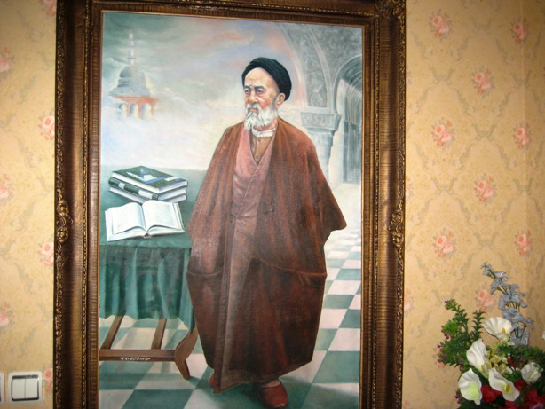

Image of Allameh ( Oil Painting. Work: Seyyed Mehdi Amin, 1991 )

CONTENTS:

BOOK THIRTY NINE

FOODS AND FEEDING

IN ISLAM

) Red Lines have been Translated! )

Part One
Human Foods and Feeding

Chapter One: An Introduction to Devising Human Food

Stages of Devising and Creation of Human Food
Rain and Wind as Resources of Human Food
Divine Commandment about Human Food at Beginning of Human Creation
Pleasure in Food and in Marriage, its Truth and Philosophy
The Truth of Love for Food
Lust for Food, the Abstinence, and the Divine Virtue
What does Blessing in Food Mean?
The Importance of Human Food among all Gifts of God
A Narrative about the Principles of Feeding in Islaem
The Truth of Feeding Food in the Way of God
The Special Law of Feeding the Devoting Worshipers
Equal Use of Believers and Unbelievers from Divine Sustenance
Meaning of God's Creating Beautiful Gifts and Pure Sustenance
Who is the Bestower of Sustenance?
All Living Creatures' Sustenance is Undertaken by God!
Honoring Adam's Generation with Delicious and Clean Foods
Trust on God for His Bestowing Sustenance
Taming the Land for Human Use and Nutrition

Chapter Two: Meat in Human Nutrition
Permission to Feed Human Beings from Animal Meats
Creation of Livestock for Human Riding and Nourishment
Permission to Eat from Adult and Young Livestock Meat
Fresh and Soft Sea Foods
Beliefs of Different Nations and Religions about Eating the Meat
Nutrition of Flesh in Buddhism
Nutrition of Flesh in the Arabic Traditions of Ignorance Era
Nutrition of Flesh in the Tradition of Chinese Idolaters
Nutrition of Flesh in the Religion of Islam

Chapter Three: Allowable and Forbidden Foods
An Interpretation of Imam Sadiq(AS) on the Philosophy of Forbidden Foods
A Decree to Eat Allowable and Clean Foods of the Ground
Warning to Believers to Use of God's Allowable Sustenance
Reasons for Refusing some People to Eat some Foods
All the Meat of Livestock is Allowed, Except ....
Why the Allowable Meats Become Forbidden?
Sanctions of Blood and Three Types of Meat
Announcement of Uncleanness of the Pork
Types of Carrion and Forbidden Slaughters
Reason to Forbid the Carrion
Non-Monopoly of the Four Sanctions
Narrations about Adversity Conditions
Avoiding to Forbid what God has Allowed
Foods of the People of the Book being Allowable
Narrations about the Foods of the People of the Book
Conditions and Reasons to Allow the Foods of the People of the Book
A Warning about the Foods of the People of the Book
Forbidden Foods for the Children of Israel
Examination of Human with Allowable and Forbidden Sustenance
The Forbidden Drink
Continuation of Piety and Righteous Deeds, the Condition to Forgive the Sin of Wine Drinks before Sanction
Narrations about Wine Sanction
Commands of Ignorance Era about Agriculture and Livestock
Negation of Fabricated Commands of Ignorance Era about Animals
Eating the Fire
Change of Orphans' Property to Fire inside the Belly

Chapter Four: Islamic Slaughter
Importance of Religious Slaughtering in the Name of God
Confrontation between Slaughter and Affection, and Philosophy of Administering Slaughter in Divine Law
A Discussion on Islamic Slaughter and the Divine Mercy
Traditions in the field of Livestock Slaughter
Way of Cultivating the Half-Alive Livestock
Philosophy of Legitimizing Slaughtered Meat with Cultivation
Sanction of Ignorance Era Slaughters

Chapter Five: Foods Prepared by Meats of Hunted Animals and Birds
Hunt by Hunter Dog and its Religious Slaughter
Outcome of the Inordinate Hunting
A Narrative about Hunting with Dog and other Hunters
Meat of Sea Fishings and Desert Hunting
Allowing Sea Fishings' Meat
Philosophy of Hunting Forbid while Wearing Mecca Pilgrims' Garb
Traditions about Hunting while Wearing Mecca Pilgrims' Garb

Chapter Six: Fruits and Crops in Human Feeding
Types of Foods and Beverages Produced for Human
God is the Splitter of the Grain and the Core!
God's Oath to the Fruits
Permission to Eat Fruits and Crops
Granting the Portion of the Poor at Time of Harvesting
Prevention in Overuse of Fruits and Crops
Narrations on Right of the Poor in Fruits and Crops
Couples of the Crops
Fruits, Palms, Grains, and Flowers: God's Undeniable Blessings
Plants, Cereals and Fruits, Product of Dying and Reviving of the Earth
Variation in Colors of Fruits and Plants
Growing Factors and Stages of Plants and Crops
Agricultural Products of the Earth

Chapter Seven: The Holy Prophet's Meal (and Feeding Manner in Phrophet's Family)
The Food of the Holy Messenger of Allah
Eating and Drinking Manner of the Holy Prophet
Drinking Manner of the Holy Prophet
Manner of the Holy Prophet on Sitting for Food
Teeth Brushing Way of the Holy Prophet
Breaking Way of Holy Prophet's Fasts
"Vesal", a Fasting Special for the Holy Prophet
The Food of Holy Prophet's Household and its Preparation Mode

Chapter Eight: Stories about Food and Feeding in the Prophets' History
God's Order to His Prophets to Eat Clean Foods
Examination of the Jews by Fishing
A Historical Examination, Forbid to Drink from River's Water
Abraham,s Food Prepared for Angels
Joseph's Interpretation of Prisoners' Dream of Food
Egyptian's Food at Years of Abundance and Hardship in Dream of the King
Men of the Cave in Search of a Clean Food
Moses' Food on a Journey to Seek Khizr
Moses, and his Asking a Food in lieu of Preparing the Wall
Revelation to the Mother of Moses to Milk him

Chapter Nine: The Heavenly Foods
Mary's Heavenly Foods
Miracle of Zamzam Water
Heavenly Foods for an Exceptional Person
Christians' Heavenly Food
Traditions about the Christians' Heavenly Food
Heavenly Foods of the Children of Israel
Miracle Springs and Heavenly Foods

Chapter Ten: A Review of Foods in Paradise
Eating, Drinking and Enjoying the Lovemaking in Paradise!
The Wine, they Drink in Paradise!
From the Spring that Drink the Devoted Servants of God
The Fruit and Food of the Paradise-Dwellers, their Drink from the Spring of "Salsabil"
An Example of the Promised Paradise for the God-Fearing
Paradise with its Eternal and Abundant Waters and Fruits
From Fruits and Birds' Flesh Whatever you Like Pick and Feed
Particular Life and Heavenly Bounties of God's Purified Servants
Fruits and Heavenly Meats in Access of the God-Fearing
Assumption of no Food, Assumption of no Human Being!
Concept of Morning and Evening Dining of the Paradise-Dwellers
Concept of Security in Pursuit of Heavenly Fruit

The Translation is to be continued !

