In the Name of Allah, the Most Compassionate, the Most Merciful

ACLASSIFICATION of
ALMIZAN

THE INTERPRETATION OF HOLY QURAN

BOOK TEN
The Perceptual, Emotional, and Intellectual Systems of Human

BY: Great Allameh
Seyyed Mohammad Hossein Taba-Tabaii

Edited, Summarized, Classified, and Translated by:

Seyyed Mehdi Amin
2016

"Allameh" Ayatollah Seyyed Mohammad Hossein Taba-Tabaii
&
His Masterpiece:
" ALMIZAN, THE INTERPRETATION OF HOLY QURAN"

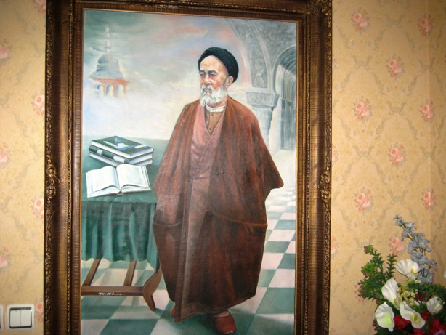

Image of Allameh ( Oil Painting. Work: Seyyed Mehdi Amin, 1370 )

CONTENTS:
) Red Lines was Translated )

BOOK Ten:
The Perceptual, Emotional, and Intellectual System of Human

Chapter One: Perceptions 6

Perceptions Granted to Human 6
Types of Human Perceptions
Types of Human Perceptions in View of Qur'an:
1- (Zann ) Thought /Guess
2- (Hosban) Counting/Calculating
3- (She'our) Common Sense/ Consciousness
4- ( Zekr ) Remembrance/ Memorize/Praising
5- (Erfan/Ma'ra'fat) Insight/Knowledge
6- (Fahm) Understanding/Comprehension
7- (Fegh'he) Jurisprudence
8- (Dera'yat/Dark) Insight/Perception
9- (Yaghin) Certainty
10- (Fekr) Thoughts/Memorize
11- (Ra'y) Opinion/Viewpoint
12- (Za'a'm) Opinion/Guess
13- ( Elm) Science/Knowledge
14- (Hefz) Preserve/Memorize
15- (Hekmat) Wisdom
16- (Khebrat) Expertness/Skillfulness
17- (Shaha'dat) Witnessing/Observing
18- ( Agh'l) Intellect/Reason/Wisdom
19- (Fatwa) Fatwa/Decree
20- ( Bacir'at) Insight/Vision

Perception of Human First Need
Human Perceptions and the Cognition of God
Disorder Agents at Human Perceptions
Human Perceptions and Emotions, the Influence Spot of Satan
Relationship of Human Perceptions with Time and Happiness
Perceptions in other Creatures

Chapter Two: Feelings and Instincts
Feelings and Instincts
Feeling of Peace and Tranquility, its Natural Basis
Feeling of Humility(Awe) and its Difference from Fear
Patients with Angst
Greed, a Genetic Sense
Human Instinct of Recruitment and Exploitation

Chapter Three: Intellectual System and Divine System of Human Thinking

Human Equipping with Devices of Feeling and Thinking
Importance of Correct Thinking in Human Life
Thinking and Perception, Intermediaries between Man and his Deeds(Human Practical Sciences)
Coordination of Logical Principles with Innate Thinking System
Human Nature: the Base of Human Thinking and Cognition System
Contradiction between Innate Awareness and Tendencies
The Role of Virtue in Human's Return to Natural System and Healthy Thinking
Effect of Man's Natural Judgment on his Intellectual Development
Kinds of Natural Pleasures and Human's Intellectual Pleasures
Genetic Adornment of Intellectual Pleasures and Deeds

Chapter Four : Visions and Dreams
Definition of Incarnation(Representation), and Reality of External Identity
Involvment of Imaginations and Perceptions in Form of Incarnation
Dream and Hadith-Breath(Self-Telling)
Difference Between Death with Sleeping
The Historical, Islamic, and Scientific Conception of Dream
Categorizing the Dreams:
1- Dreams arising of Sensual Imaginations
2- Impact of the Individual Peculiarities in Dream
3- The Real Dreams
Scientific Analysis of the Real Dreams:
1- Relation of Dreams with Outbreak of Events through Transmission
2- The Clarity Degree of Dreams
3- Exemplification and Interpretation by Counterpart or Anti-Accident
4- Confusion and Interlocking - the Sequence of Transmissions, and Difficulty in Interpreting
Dream in View of Quran

Chapter Five : Special Perceptions

Special Perceptions - Insight
Seeing with Eye and Seeing without Eyes
Insight of Human in Selfdom
What Time the Insight of Man Gets on?
The Means to Create Insight
The Veil between Human and God
Kinds of Acts Hidden from Human Sense
The Relationship of HumanWill with Supernatural
Inculcation and the Reality of Summoning the Spirits
Coordination of the Human Will with the Will of God
Special Perception of Prophecy
Differences of Special Perceptions with Intellectual and Mental Perceptions
Innocence - Deny of Fault in Special Perceptions
Understanding the Satanic or Angelic Memories or Inductions

Chapter One

Perceptions

Perceptions Granted to Human

«عَلَّــمَ الاِنْســانَ مـــا لَـــمْ يَعْلَــــمْ!» (5/علق)

"And He taught man what he did not Know !"
(Holy Quran: Alaq. 5. )

The word God, who created the human kind, entrusted within him the powers of Perception, as Eyes, Ears and Inner Senses. He granted him also an intellectual force, with which he could find information on current events, as well as the information on the past or future. And by this way he could find a kind of surrounding awareness to the events of Universe.
In Surah Alaq in Verse 5, Says:
"And He taught man what he did not Know!"

And in Surah Nahl in Verse 78 Says:

" And Allah brought you out from the wombs of your mothers when you knew nothing; and bestowed on you Hearing and Sight and Heart…!"

And in Surah Baqareh in Verse 31 Says:

" And He taught Adam all of the names [ of beings and things existing
in the whole Universe …!] "

God chose a kind of existential quality for human kind which is able to communicate with everything, and take advantage of everything, directly or by means of other equipment, as we observe it in his intellectual manners and industrial procedures, God Said:
"He is the One Who created for you all Things
that are on the earth…!"(Holy Quran. Baqareh, 29,)
Again Said:
"And Allah has subjected for you Whatever is in
the Heavens and on the Earth…!"(Holy Quran. Jacieh, 13,)

Man, by help of his intellectual power and conquering relationship with all other creatures, has succeeded to provide a bunch of nominal sciences to possess the objects and to effect on the creatures outside himself, to take use of them in his existence and survival.
(Almizan v. 3, p. 162.)

Translation is to be continued !!

